Does Replay Emerge in Fast and Slow Recurrent Networks Learning a Hidden Structure?
[PH] Anonymous authors (double-blind review)
Abstract
Complementary Learning Systems theory proposes that a fast, low-capacity hippocampus replays recent experience during sleep to train a slow, high-capacity neocortex, but computational models usually build replay in by design. We asked whether replay emerges on its own. We trained fast and slow recurrent networks to denoise sequences from an artificial grammar, alternating input-driven “day” periods with input-free “night” periods that were excluded from the loss. Night activity in the fast module was structured: it followed the grammar ([PH]), [PH] (repeated past sequences / generated new grammatical ones), was time-compressed ([PH]), and predicted next-day learning in the slow module ([PH]). Removing nights impaired performance ([PH]). Replay can thus emerge as a learned strategy for consolidation.
Introduction
Sensory input is often noisy and ambiguous. In a loud bar, for example, a listener can still understand that someone said “I want a cup of coffee”, even if the last word was barely audible. This is possible because the listener has an internal model of the language and of what is likely to be said next. Such internal, or generative, models help the brain infer what caused the input it receives. However, they cannot be learned in one day, which raises the question of how the brain builds them from limited and sequential experience.
Complementary Learning Systems (CLS) theory offers one answer (McClelland et al., 1995). According to this theory, learning new information quickly in a single network would interfere with what the network already knows. The brain may avoid this problem by using two systems. The hippocampus learns quickly and keeps memories separate, but its capacity is limited. The neocortex learns slowly and extracts regularities across many experiences. During offline periods such as sleep, the hippocampus reactivates recent experiences, and the neocortex can gradually learn from them without overwriting older knowledge.
Hippocampal replay is a likely mechanism for this transfer. Wilson and McNaughton (1994) showed that hippocampal neurons that were active together while rats explored an environment remained active together during later sleep. Lee and Wilson (2002) then showed that sequences of place cells are replayed during slow-wave sleep in the same order as during behaviour, but much faster. More recently, Spens and Burgess (2024) modelled consolidation as hippocampal replay training a generative model in the neocortex, which explains semantic memory, imagination and some memory distortions. Schapiro et al. (2017) showed that the hippocampus is not only a store of separate episodes: one of its pathways can also extract regularities within minutes, and they suggested that this may influence which experiences are replayed.
In most of these models, however, replay is part of the model design: it is decided in advance that the hippocampus replays memories and that these replays train the neocortex. It is less clear whether a learning system would develop replay by itself when facing the problem described by CLS. Here we trained a fast, small recurrent network and a slow, larger recurrent network together to recover sequences generated by an artificial grammar from noisy input. During “night” periods, the networks received no input and no training signal. This allowed us to ask whether replay-like activity appears without being imposed, and whether it repeats past experience or generates new sequences that follow the learned structure.
Methods
Generative Process Sequences were produced by a probabilistic artificial grammar with [PH] hidden states (“words”). From each state, the grammar could move to [PH] possible next states, so the next element was constrained but not fully determined, as in language. Each hidden state produced a [PH]-dimensional vector sampled from a Gaussian distribution with a state-specific mean (SD = [PH]). Observations were then corrupted with additive Gaussian noise (σ = [PH]). Grammar complexity was chosen so that the fast module alone could not learn the grammar within one day.
Architecture The system had three recurrent modules (Figure 1A): a perceptual module (perc) that received the noisy observations and output the inferred vector, a fast module ([PH] units) and a slow module ([PH] units), connected as follows: [PH]. All modules were [PH] (e.g., GRU) networks implemented in PyTorch. The fast module differed from the slow module in [PH] (e.g., size, learning rate, plasticity).
Training Training was organised in cycles. Each cycle started with a day of [PH] time steps, in which the system received noisy observations and was trained to output the true vectors (mean squared error). The day was followed by a night of [PH] time steps with no input; night activity was not included in the loss. Gradients were computed over the whole day–night–day sequence and weights were updated once per cycle ([PH] optimiser, learning rate [PH], [PH] cycles, [PH] random seeds).
Analyses After training, weights were frozen. Linear decoders fitted to daytime hidden states were used to decode the grammar state from night-time activity in each module. Decoded night sequences were scored by their likelihood under the true grammar and by their overlap with the previous day’s sequences, and compared with time-shuffled sequences and untrained networks. To test function, we related night content to next-day improvement and ran ablations: no night periods, and fast-to-slow connections cut during the night.
Results
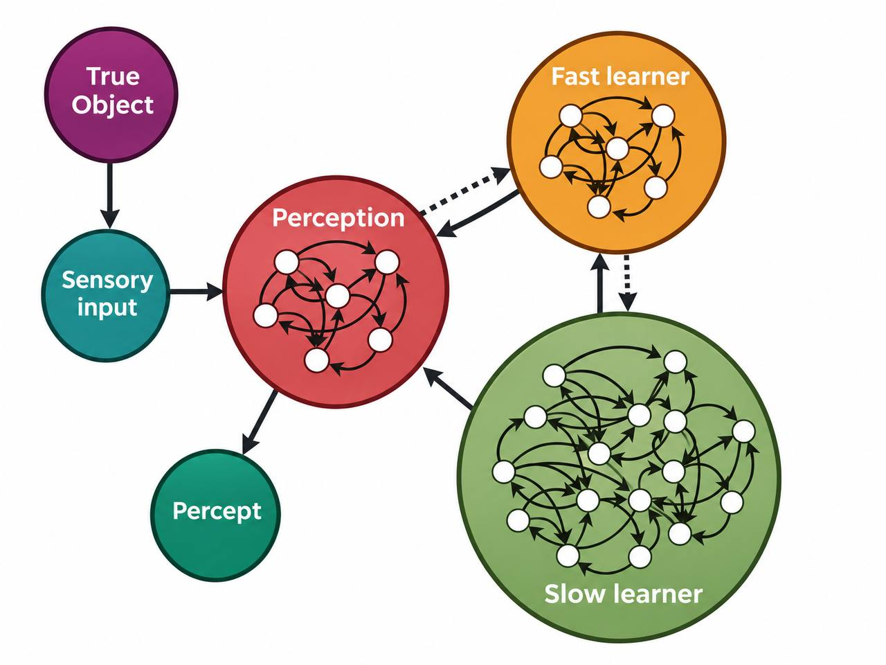
Figure 1: (A) Architecture and day–night training cycle. (B) Example of a decoded night sequence compared with the previous day. (C) Performance of the full system, single modules and ablations. [PH]
The full system recovered the true sequences well, reaching [PH] (e.g., decoding accuracy / MSE), compared with [PH] for the fast module alone, [PH] for the slow module alone and [PH] for a system trained without nights (Figure 1C).
Night-time activity in the fast module was structured. Decoded night sequences had a higher likelihood under the grammar than time-shuffled sequences ([PH]) and than night activity in untrained networks ([PH]). Night transitions occurred about [PH] times faster than daytime transitions, similar to the time compression of hippocampal replay (Lee & Wilson, 2002). [PH]% of night sequences repeated sequences from the previous day, while [PH]% were new sequences that still followed the grammar (Figure 1B), suggesting that the fast module [PH] (mostly repeated past experience / mostly generated new samples from the learned structure).
Night activity was also useful for learning. The grammaticality of night sequences predicted the next-day improvement of the slow module ([PH]). Removing night periods reduced performance by [PH], and cutting fast-to-slow connections during the night reduced it by [PH]. Finally, high-probability transitions were over-represented in night sequences ([PH]), in line with the idea that statistical learning shapes which experiences are replayed (Schapiro et al., 2017).
Discussion
[PH]
Acknowledgments
References
Lee, A. K., & Wilson, M. A. (2002). Memory of sequential experience in the hippocampus during slow wave sleep. Neuron, 36(6), 1183–1194.
McClelland, J. L., McNaughton, B. L., & O’Reilly, R. C. (1995). Why there are complementary learning systems in the hippocampus and neocortex: Insights from the successes and failures of connectionist models of learning and memory. Psychological Review, 102(3), 419–457.
Schapiro, A. C., Turk-Browne, N. B., Botvinick, M. M., & Norman, K. A. (2017). Complementary learning systems within the hippocampus: A neural network modelling approach to reconciling episodic memory with statistical learning. Philosophical Transactions of the Royal Society B, 372(1711), 20160049.
Spens, E., & Burgess, N. (2024). A generative model of memory construction and consolidation. Nature Human Behaviour, 8(3), 526–543.
Wilson, M. A., & McNaughton, B. L. (1994). Reactivation of hippocampal ensemble memories during sleep. Science, 265(5172), 676–679.

